Role Management

Use case Document

Submitted to

Alpha Payments Cloud


Tarang Software Technologies Private Limited
Tarang Towers,
#400/2, Whitefield 100 ft road,
Hoody circle,
Bangalore, India
Phone: +91-80-41157777
WEB: www.tarangtech.com

© This document is exclusive property of Tarang software Technologies Private Limited. No part of this may reproduced in any form without written permission.

Document Change History

Ver# | Editor | Date | Reviewer | Approver | Changes made
0.1 | Sadanandh | 3rd Sept 2012 | Bindu |  | Draft version
1.0 | Sadanandh | 7th Sept 2012 | Bindu |  | Base version
1.01 | Sadanandh | 18th Sep 2012 | Ronan |  | Updated with review comments
Table of Contents
1 Introduction 4
2 Use Case: SEARCH Roles 4
2.1 User Interface Information 5
2.1.1 User Interface details for search roles 5
3 Use Case: Add ROLE 5
3.1 User Interface Information 6
3.1.1 User Interface details for Add Role 6
4 Use Case: Edit Role 7
4.1 User Interface Information 8
4.1.1 User Interface details for Edit Role 8
5 Use Case: View User List 8
5.1 User Interface Information 9
5.1.1 User Interface details for View user List 9

Introduction

This document describes all the use cases for User Management. It includes search Role, Add/Edit Role,

Use Case: SEARCH Roles

Title | Search Role
Requirement ID | RID-1041
Actors | System Admin, APC User with appropriate privilege to search roles
Description | Actor should be able to search for the roles
Use case trigger | - When Actor selects the “Manage Roles” option from the main menu to search for the Roles
Main flow / Flow of Events | - On choosing the “Manage Roles “ option from the main menu, system shall display the list of recently created 20 roles Page which shall include the search criteria’s:  Role Name and Status  Action - Search  - Actor shall enter the search criteria & click on “Search” button.  - System shall build the query based on the criteria entered & retrieve the relevant records from the DB & display it in the listing in the below mentioned format:  [Role Name, Role Description, Status, Created By, Created Date, Modified By and Modified Date, User List]
Sub-flow/Alternate Flows/ Scenarios | 2a. If the actor does not choose to enter any data in the search criteria’s then the system shall retrieve all the role records.  2b. If there are no relevant records for the search criteria chosen; system should display an appropriate message saying “No Records found.”  2c. Depending on the status criteria chosen, Active/Inactive only the roles in the respective status should be retrieved.  3a. If the actor selects the row and clicks on edit link at the bottom of the table or double click on the selected row, system should navigate the actor to the corresponding user edit screen. This feature will detailed out as part of separate use case.  3b.If the actor clicks on the “Add Role” link at the bottom of the table, system should navigate the actor to the Add Role screen. This feature will detailed out as part of separate use case.  3c. If the actor clicks on the “View” button under the user list column, system should navigate the actor to the Manage user screen with the user list for the corresponding Role. This feature will be detailed as part of separate use case.
Assumptions
Pre-conditions | Actor should be logged into the system & has the appropriate privilege to manage roles.
Post-conditions | - Actor is able to retrieve the relevant role records from the system based on the search criteria chosen.
Status | open
Issues | None
Business Rules | Search – Query should be for partial search. I.e. like “%string%”. So the minimal search keys that you enter should retrieve the maximum information. For ex: Search By username – “CAR” should retrieve all the roles with the alphabet “car” in their names.

User Interface Information

User Interface details for search roles

Please refer Manage Roles screen in the story board

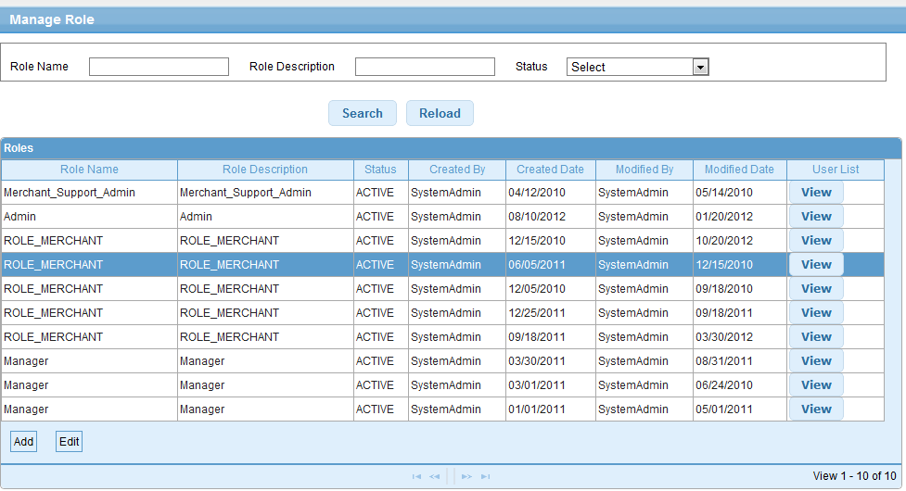

Use Case: Add ROLE

Title | Add Role
Requirement ID | RID-1042
Actors | System Admin, APC User with appropriate privilege to Add roles
Description | Allows the actor to add a Role.
Use case trigger | - Actor chooses to click on “Add Role” link/button from the Role listing screen (Manage Roles)
Main flow / Flow of Events | - System shall navigate the actor to the Add Role screen along with the following fields to be captured/ updated.  - details of the fields shown are:  - Role Name  - Role Description  - List of Modules with their permissions  - Actor shall enter the relevant information and selects one or more permissions from list & Click on Save.
Su  b-flow/Alternate Flows/ Scenarios | 3a.If the actor do not select at least one permission for the role, appropriate error message like “At least one permission need to be selected” is displayed  3b. Create Role – If the Actor doesn’t find the suitable role during user creation, actor clicks on  Create New Role button on Add User Screen.
Assumptions | Actor is logged into the System and has the permission to create new role
Pre-conditions | The actor is logged in to the application with appropriate permissions
Post-conditions | - Add - New Role will successfully be created in the system and the Actor will be navigated to the Role listing screen with the newly created role details.  - Create New Role (Add User): New Role will be added to role drop down as selected one.
Status | Open
Issues
Business Rules | System Admin and the user who has the permission to create the new roles only can create the new roles.  The actor needs to select one or more permission from the role permission list to save a new role.  A single Role can’t have create and approve permissions together in order to follow the maker and checker process.  Ex : for Merchant On boarding, new merchant cannot be created and approved by the same user

User Interface Information

User Interface details for Add Role

Please refer the Manage Roles>>Add Role screen in the story board

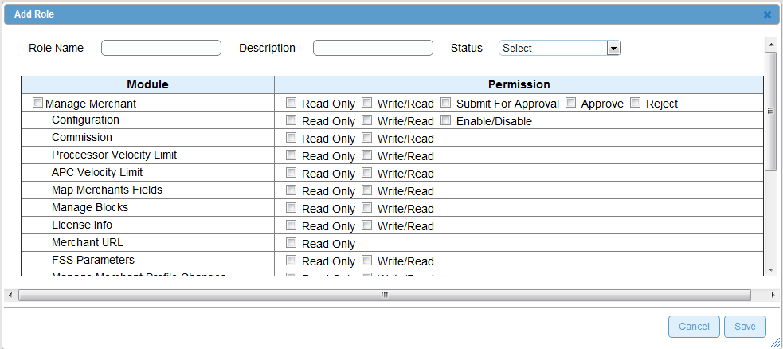

Validations for Add Role

Id | Parameter Name | Field Type | Special characters | Validations | Field Length | Possible Values | Additional Condition | Mandatory
1 | Role Name | Textbox | No | Alpha | 20 |  |  | Yes
2 | Role Description  Module & Permissions | Text  Area  Check boxes | Yes  N/A | Alpha  N/A | 200 |  |  | Yes

Use Case: Edit Role

Title | Edit Role
Requirement ID | RID-1043
Actors | System Admin, APC User with appropriate privilege to Edit Roles
Description | Allows the Actor to Edit Role details
Use case trigger | - Actor selects the row from the role listing grid and clicks on the Edit link at the bottom of the table or double click on a selected row in the role list.
Main flow / Flow of Events | System shall navigate the actor to the Edit Role screen along with the following fields to be updated.  details of the fields with the existing values shown are:  - Role Name  - Role Description  - Modules & Permissions  - Status(Active or Inactive)  Actor shall update the Role description and add or remove permissions of the fields & clicks on Edit button.
Sub-flow/Alternate Flows/ Scenarios | If the user enters the invalid data, the system will navigate the actor to the same screen with appropriate error message.
Assumptions | Actor is logged into the application & has the permission to Edit Roles.
Pre-conditions | Actor is logged into the system & is in the role list screen
Post-conditions | The fields which are modified will be updated in the DB and the Actor will be navigated to the Manage Roles screen.
Status | Open
Issues | None
Business Rules | System Admin Role cannot be modified.  Role Name cannot be modified.  At least one permission need to be selected for the role  Role cannot be made inactive if it is assigned to any user

User Interface Information

User Interface details for Edit Role
Same as Add Role screen of the storyboard

Validations for Edit Role

 | Parameter Name | Field Type | Special characters | Validations | Field Length | Possible Values | Additional Condition | Mandatory
Id | Parameter Name | Field Type | Special characters | Validations | Field Length | Possible Values | Additional Condition | Mandatory
1 | Role Name | Textbox | No | Alpha | 20 |  |  | Yes
2 | Role Description  Module & Permissions | Text  Area  Check boxes | Yes  N/A | Alpha  N/A | 200 |  |  | Yes

Use Case: View User List

Title | View User List
Requirement ID | RID-1044
Actors | System Admin, APC User with appropriate privilege to View user List for a Role
Description | Allows the Actor to View user list for the selected Role
Use case trigger | - Actor selects the row from the Role listing grid and clicks on the View link in the User List Column
Main flow / Flow of Events | System shall navigate the actor to the User List screen along with the following fields displayed for the selected Role  [User Name, Role, e-mail, Contact No, Hierarchy, Country and Status].
Sub-flow/Alternate Flows/ Scenarios | If the Actor clicks on the Role with no user associated with the selected role, the Actor shall be navigated to the same screen with the message – “no user associated with the selected Role”.
Assumptions | There exists at least one role in the system.
Pre-conditions | Actor is logged into the system and has the permission to view user list for the selected role.
Post-conditions | Display of the user list for the selected Role
Status | Open
Issues | None
Business Rules | List the user list for the selected role

User Interface Information

User Interface details for View user List
Refer user List screen of storyboard

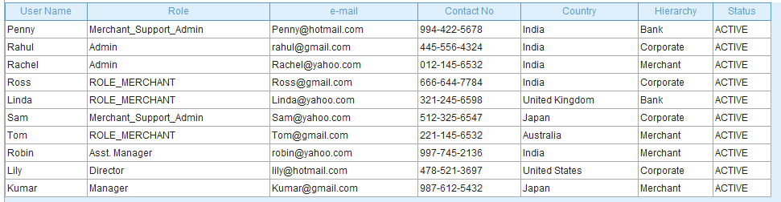

Validations for View user List

None

